Modifications to the Laws of the Game

Small-Sided Games
2021

7 v 7
Birth years 2010 (U9) and 2009 (U10)
Law 1 – The Field of Play
- Build-Out Line. A Build-Out Line is a line across the width of the field of play mid-way between the top of the penalty area and the half-way line in each half. They should be equidistant between the penalty area line and the halfway line.
  - When the goalkeeper has the ball in his or her hands during play from the opponent, the opposing team must move behind the build out line until the ball is put into play.
  - Once the opposing team is behind the build out line, the goalkeeper can pass, throw or roll the ball into play (punts and drop kicks are not allowed).
  - After the ball is put into play by the goalkeeper, the opposing team can cross the build out line and play resumes as normal.

- 55-65 yards (length) and 35-45 yards (width)
- Goals should be no larger than 6.5 feet (height) x 18.5 feet (width) - A 6.5 feet (height) x 12 feet (width) goal is recommended based on the age and ability of the players
- Diagram with the recommended field markings and dimensions.
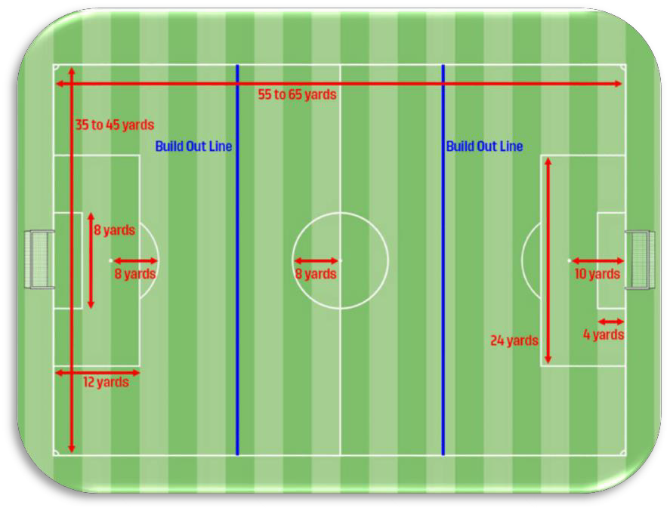

Law 2 – Ball
- Size 4

Law 3 – Players
- 7v7 (6 field players and 1 goalkeeper).

- Game may not start or continue if there are less than 5 players on a team.
- Substitutions are unlimited and can occur at any stoppage.

Law 5 – Referee
- Minimum certification as a U.S. Soccer Grade 9 Referee.

Law 6 – Other Match Officials
- Used at the discretion of the competition.

Law 7 – Duration of the Match
- 2 halves
- 25-minute halves
- 10-minute halftime
- No added time

Law 11 – Offside
- The build out line will be used to assess where offside offenses can be punished.
- Players cannot be penalized for an offside offense between the halfway line and the build out line.
- Players can be penalized for an offside offense between the build out line and the goal line.

Law 12 – Fouls and Misconduct
- No Deliberate heading of the ball. For deliberate heading, the restart is an IFK to the opponent.
- The ball is dropped to the defending team goalkeeper in their penalty area if, when play was stopped:
  - the ball was in the penalty area or
  - the last touch of the ball was in the penalty area

Law 13 – Free Kicks
- If a goalkeeper punts or drop-kicks the ball within the penalty area, an indirect free kick will be awarded to the opponent to be taken from the penalty area line parallel to the goal line at the nearest point to where the offense occurred.
- If a goalkeeper punts or drop-kicks the ball outside the penalty area, a direct free kick will be awarded for handling to the opponent from the location of the offense. (This punishment will only be considered by the referee if the goalkeeper steps outside the penalty area holding the ball on his/her on hands before punting or drop-kicking the ball).

Law 16 – Goal Kick
- The opposing team must move behind the build out line during a goal kick until the ball is put into play.

Standard Laws of the Game
Law 4 – Players Equipment
Law 8 – The Start and Restart of Play Law 9 – The Ball in and Out of Play

Law 10 – Determining the Outcome of a Match Law 14 – The Penalty Kick
Law 15 – The Throw-in Law 17 – The Corner Kick

