9 v 9

Modifications to the Laws of the Game Small-Sided Games

Birth years 2010 (U11) and 2009 (U12) –Game
Law 1 – The Field of Play

- 70-80 yards (length) with 45-55 yards (width)
- Goals should be no larger than 7 feet (height) x 21 feet (width) - A 6.5 feet (height) x
18.5 feet (width) goal is recommended based on the age and ability of the players
- Diagram with the recommended field markings and dimensions:
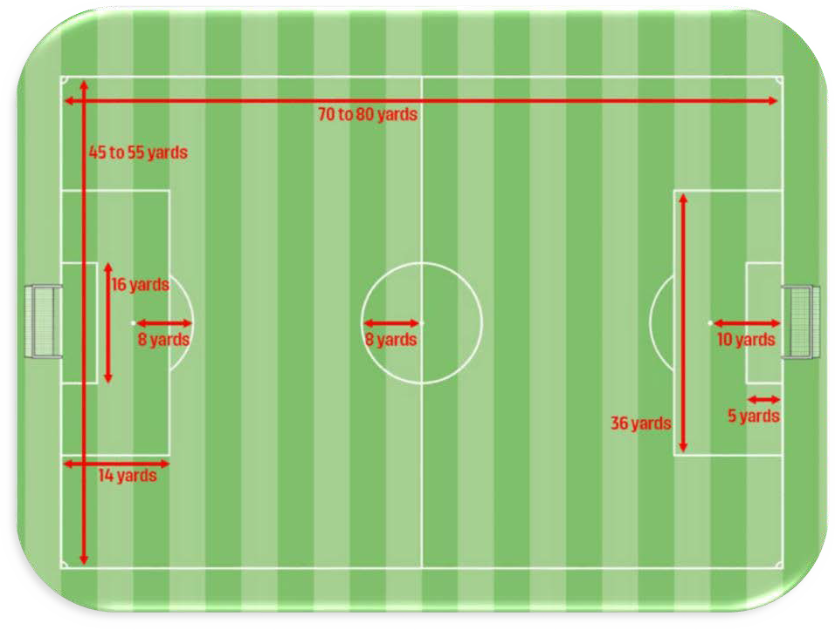

Law 2 – Ball
- Size 4

Law 3 – The Players
- 9v9 (8 field players and 1 goalkeeper)
- Game may not start or continue if there are less than 6 players on a team
- Substitutions are unlimited and can occur at any stoppage

Law 5 – Referee
- Minimum certification as a U.S. Soccer Grade 9 Referee.

Law 6 – Other Match Officials
- Used at the discretion of the competition.

Law 7 – Duration of the Match
- 2 halves
- 30-minute halves
- 10-minute halftime
- No added time

Law 8 – The Start and Restart of Play

- If a player is struck in the head by the ball accidentally, the referee will assess the force of the impact and if the referee stops the game because of the strike/blow to the head,

– The referee restarts the game with a dropped ball in accordance with Law 8.

The hit to the head will be considered accidental if when the ball hits the player’s head, it occurred in a way that was not planned or intended; happening by accident. The player may be standing still or in motion but not in either case playing the ball. The player may not even be aware that the ball is coming in a direction from which contact is imminent.

The ball is dropped to the defending team goalkeeper in their penalty area and/if when play was stopped: the ball was in the penalty area or the last touch of the ball was in the penalty area.

Law 12 – Fouls and Misconduct
- Deliberate heading is not allowed in U11 (2010) games
• If a player deliberately heads the ball in a game, an indirect free kick will be awarded to the opposing team from the location of the offense.
• The ball is dropped to the defending team goalkeeper in their penalty area if, when play was stopped:
- the ball was in the penalty area or
- the last touch of the ball was in the penalty area
Standard Laws of the Game

Law 4 - Players Equipment
Law 8 - The Start and Restart of Play Law 9 - The Ball in and Out of Play
Law 10 - Determining the Outcome of a Match Law 11 - Offside
Law 13 - Free Kicks
Law 14 - The Penalty Kick Law 15 - The Throw-in Law 16 - The Goal Kick Law 17 - The Corner Kick

